**Assignment No: - 1**

**Feed-Forward Neural Network**

**Problem Statement:**

Implementing Feedforward neural networks in Python using Keras and TensorFlow.

**Objectives:**

1. To implement a Feed-Forward Neural Network (FFNN) using Python, Keras, and TensorFlow.
2. To understand how FFNNs work and are trained using backpropagation.
3. To explore how FFNNs can be used for tasks such as classification, regression, and pattern recognition.

**Theory:**

A **Feed-Forward Neural Network (FFNN)** is the simplest form of artificial neural network where information moves in one direction: from input nodes, through hidden nodes, and to output nodes. There are no cycles or loops in the network. FFNNs are primarily used for supervised learning tasks and are trained using a process known as backpropagation, where the model adjusts weights based on the error in its predictions.

Each neuron in the network takes inputs, applies a weight to each, sums them up, applies an activation function (e.g., ReLU, Sigmoid), and produces an output that gets passed to the next layer.

**Methodology:**

1. **Problem Definition**: Define the task (e.g., image classification, regression) and gather the necessary dataset.
2. **Data Preprocessing**: Normalize and preprocess the data so it can be fed into the neural network.
3. **Neural Network Architecture**:
   * Input Layer: Accepts the input features (dimensions depend on the dataset).
   * Hidden Layers: One or more layers of neurons with activation functions to introduce non-linearity.
   * Output Layer: Produces the final output (classification probabilities or regression values).
4. **Model Training**:
   * Define loss function (e.g., categorical cross-entropy, mean squared error).
   * Use **backpropagation** and **gradient descent** to minimize the loss by updating the weights.
5. **Implementation**: Use Keras and TensorFlow to define the FFNN architecture and train the model.
6. **Evaluation**: After training, evaluate the model on the test set to check its accuracy or performance.

**Working Principle / Algorithm:**

1. **Initialize the Network**: Define the number of layers, neurons in each layer, activation functions, and the loss function.
2. **Feed-Forward Pass**:
   * Inputs are passed from the input layer, through the hidden layers, to the output layer.
   * At each layer, the weighted sum of inputs is calculated, and an activation function is applied.
3. **Loss Calculation**: The difference between the predicted output and the actual target value is computed using the loss function.
4. **Backpropagation**:
   * The error is propagated back through the network, adjusting the weights based on the gradient of the loss function with respect to each weight.
5. **Weight Update**: Update weights using gradient descent or a variant (e.g., Adam optimizer).
6. **Repeat**: Continue the feed-forward and backpropagation steps for multiple epochs until the model converges (i.e., the loss stabilizes).

**Advantages:**

1. **Universal Function Approximation**: FFNNs are capable of approximating any function given sufficient hidden layers and neurons.
2. **Simplicity**: FFNNs are relatively simple to implement and understand, making them a good starting point for neural network models.
3. **Versatile Applications**: Can be used for both classification and regression tasks in various domains like finance, healthcare, and image recognition.

**Disadvantages / Limitations:**

1. **Requires Large Datasets**: FFNNs typically require large amounts of labeled data to perform well, especially for complex tasks.
2. **Computationally Expensive**: Training deep networks can be time-consuming and resource-intensive, especially for large datasets or networks with many layers.
3. **Prone to Overfitting**: If not properly regularized, FFNNs can overfit to the training data, leading to poor generalization on unseen data.
4. **Vanishing Gradient Problem**: As networks grow deeper, the gradient used for updating weights may become very small, slowing or halting learning.

**Diagram:**

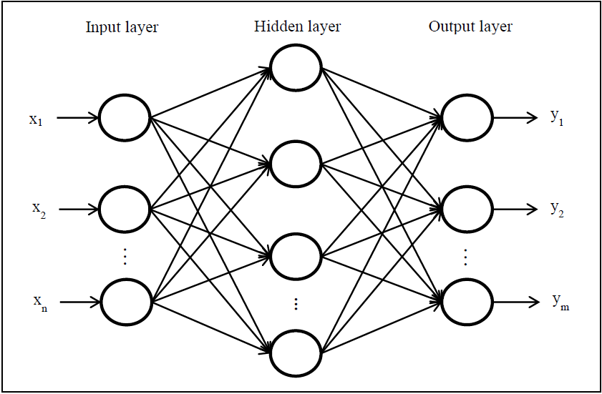

**Conclusion:**

In conclusion, the Feedforward Neural Network (FNN) algorithm is a powerful and versatile approach to predictive modeling, especially suited for both classification and regression tasks, such as predicting wine quality based on various chemical features. By utilizing its ability to learn complex, non-linear relationships between inputs and outputs, FNN can provide valuable predictions and insights that can drive decision-making. However, it's important to consider the limitations of FNN, such as the need for significant computational resources, the risk of overfitting, and the necessity of careful tuning of hyperparameters to ensure optimal performance. Despite these challenges, FNN remains a highly effective model for complex data scenarios when appropriately managed and applied.